**Case Study – 9  
(25 points)**

**Name: Patrick Woodrum**

**Clemson ID: C79975506**

**Submission**: Save this Word document with your answers as a PDF file and upload the PDF file to Canvas.

(5 pts) List all the entities for the Book Exchange Project.

**Entities for Book Exchange Project:**

**-Moderators/Administrators**

**-Members**

**-Guests/Visitors**

**-Books**

**-Library**

**-Forums**

(10 pts) Create an ERD for the Book Exchange Project with cardinality like that shown in Fig 9.19

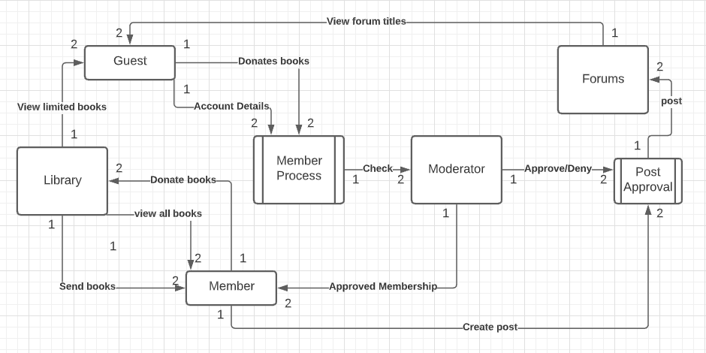

(10 pts) Design 3NF tables for the Book Exchange Project based on your ERD, make sure the Primary Keys and Foreign Keys are identified. You can use a graphical notation or standard format to express your design.

|  |  |  |  |
| --- | --- | --- | --- |
| **Book Number** | Book Name | Genre | Availability |
| 1 | Willy Wonka | Fantasy | Yes |
| 2 | Snowden | Nonfiction | Yes |
| 3 | Lord of the Rings | Fantasy/Adventure | No |

|  |  |  |
| --- | --- | --- |
| **Moderator Number** | Moderator Username | Moderation Area |
| 1 | BigMod438 | Forums |
| 2 | JimBoy21 | Membership |
| 3 | AdminGuy92 | Donations |

|  |  |  |
| --- | --- | --- |
| **User Number** | Username | Membership Status |
| 23 | EarlyBird | No |
| 456 | JohnCena85 | Yes |
| 645 | ThatOneGuy00 | Yes |

|  |  |  |
| --- | --- | --- |
| **Forum Number** | Forum Topic | Forum Posts |
| 2 | Favorite Books | 534 |
| 3 | Book Reviews | 6453 |
| 5 | Donations | 26 |